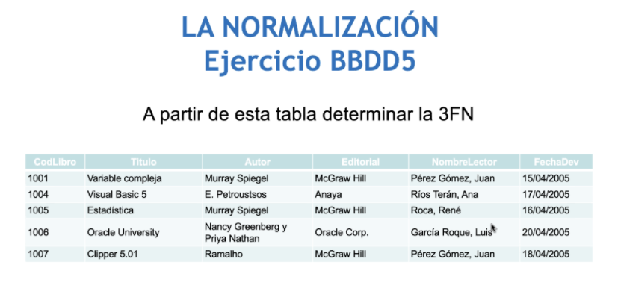

**Libro**

|  |  |  |
| --- | --- | --- |
| Cod Libro | Título | Editorial |
| 1001 | Variable Compleja | McGraw Hill |
| 1004 | Visual Basic 5 | Anaya |
| 1005 | Estadística | McGraw Hill |
| 1006 | Oracle University | Oracle Corp |
| 1007 | Clipper 5.01 | McGraw Hill |

**Lector**

|  |  |  |  |
| --- | --- | --- | --- |
| IdLector | Nombre | Ape1 | Ape2 |
| 01 | Juan | Pérez | Gómez |
| 02 | Ana | Ríos | Terán |
| 03 | René | Roca |  |
| 04 | Luis | García | Roque |

**Autor**

|  |  |  |
| --- | --- | --- |
| idAutor | Nombre | Ape1 |
| 01 | Murray | Spiegel |
| 02 | Edward | Petroustsos |
| 03 | Nancy | Greenberg |
| 04 | Priya | Nathan |
| 05 | Ramalho |  |

**Autor-Libro**

|  |  |  |
| --- | --- | --- |
| IdAutor-Libro | CodLibro | idAutor |
| 01 | 1001 | 01 |
| 02 | 1004 | 02 |
| 03 | 1005 | 01 |
| 04 | 1006 | 03 |
| 05 | 1006 | 04 |
| 06 | 1007 | 05 |

|  |  |  |
| --- | --- | --- |
| ID-Autor-Libro | IdLector | FechaDev |
| 01 | 01 | 15/04/2005 |
| 02 | 02 | 17/04/2005 |
| 03 | 03 | 16/04/2005 |
| 04 | 04 | 20/04/2005 |
| 05 | 04 | 20/04/2005 |
| 06 | 01 | 18/04/2005 |

**TABLA GRAL**